

Padification srs

Date: 2017-06-13

Version: 0.11.4

McKenzie College SWTS2102

1. Revision History

|  |  |  |  |
| --- | --- | --- | --- |
| Date | Author | Version | Revision Notes |
| 2017-06-06 | William Gale | 0.1 | Heading layout for document. |
| 2017-06-06 | Elie Godbout | 0.2 | Added Sections 2 and 3 being; Conformance and Normative references. |
| 2017-06-06 | Zachary Blue | 0.3 | Added Scope and Definitions, Abbreviations and Acronyms. |
| 2017-06-07 | William Gale | 0.4 | Integrated Player Concept into Section 5.1, Updated Revision History Layout, and Title Page. |
| 2017-06-07 | Elie Godbout | 0.5 | Integrated the Game Overview Concept in section 5.1. |
| 2017-06-07 | Kyle Gunton | 0.6 | Integrated section 5.1.3 Dungeons Overview Concept in section 5.1. |
| 2017-06-07 | Zachary Blue | 0.7 | Integrated the Mailbox Overview Concept in section 5.1. |
| 2017-06-07 | Ryan Breau | 0.8 | Integrated the Friend Overview Concept in section 5.1. |
| 2017-06-07 | Elie Godbout | 0.8.1 | Updates to section 5.1.1 (Game overview) Android device requirements updated to 4.0 and higher, egg machine section now explains what types of in-game currency are required to operate the specific types off egg machines. |
| 2017-06-07 | William Gale | 0.8.2 | Updated section 5.1.2 (Player Overview) Improved Definition of Rank, Removed Balloons from figure, Added descriptive location in definitions. |
| 2017-06-08 | Ryan Breau | 0.8.3 | Updated section 5.1.5 (Friends): Improved explanations, changed figures. Integrated section 5.1.6 (Game Currency). |
| 2017-06-08 | William Gale | 0.8.4 | Integrated (Monster) as section 5.1.3 and sub sections for Experience and Leveling, Base Stats, And Bonus Stats. Modified TOC to display 4 headings deep. |
| 2017-06-08 | Elie Godbout | 0.8.5 | Integrated sub-sections of Monster to section 5.1.3. Sub-sections: Assists, Rarity, Monster ID, Monster name, Monster box, Monster book and Selling monsters. Added image to title page. |
| 2017-06-08 | Zachary Blue | 0.8.6 | Added more information to the mail section describing the functions and areas more, moved the mail images to the right side of the page, integrated section 5.1.8 Egg Machines, updated structure |
| 2017-06-08 | Kyle Gunton | 0.8.7 | Integrated updates to section 5.1.4 (Dungeons): updated order of dungeons. Changed in-dungeon content to Dungeon Entrance, Dungeon Gameplay and Dungeon Completion.  Integrated Evolution, Power-Up/Fusion, Attributes, Types, And Skills sections to 5.1.3 (Monster) |
| 2017-06-08 | William Gale | 0.9.0 | Modified Revision History to have more room for Notes. Applied Cosmetic changes to title page, Re-arranged sub sections of Monster, and moved Monster box and Monster book to Player Section. |
| 2017-06-08 | Ryan Breau | 0.9.1 | Fixed issues with sections 5.1.6 and 5.1.7. |
| 2017-06-08 | Elie Godbout | 0.9.2 | Updated section 5.1.1 (Game Overview): Formatting, moved rewards to Dungeon Completion. Updated section 5.1.3 (Monster): Added a description for Monsters, new descriptions for Monster Number ID, Monster name and Rarity, and Clarified Monster Assists. |
| 2017-06-09 | Kyle Gunton | 0.9.3 | Updated section 5.1.4 (Dungeon): Formatting, simplified descriptions for Shop and Machine and section 5.1.3 (Monster): Formatting, moved Power-Up Fusion and Evolutions below Monster stats. |
| 2017-06-09 | William Gale | 0.9.4 | Integrated Section Navigation as section 5.1.2, |
| 2017-06-09 | Elie Godbout | 0.9.5 | Integrated Multiplayer Mode in Section 5.1.8 (Dungeons) as section 5.1.8.9 |
| 2017-06-09 | Kyle Gunton | 0.9.6 | Integrated Teams in Section 5.1.4 (Monsters) as section 5.1.4.12  Moved Team Status from friends to teams |
| 2017-06-09 | Ryan Breau | 0.9.7 | Integrated Section 5.1.9 Shops. |
| 2017-06-09 | Zachary Blue | 0.9.8 | Integrated Section 5.1.6 Quests, changed egg machine description to be more detailed, changed Mail to Mail System |
| 2017-06-11 | William Gale | 0.10.0 | Fixed Header alignment on revision Table, Broke Navigation Sub Sections into the appropriate sections, Trimmed information on Navigation UMLs and changed to Horizontal. Moved all images into margins to stop cut-off. |
| 2017-06-11 | William Gale | 0.10.1 | Integrated Processes “Power-Up Fusion” and “Evolution” into Section 6.1, Moved “Selling Monsters” into 6.1 |
| 2017-06-12 | Ryan Breau | 0.10.2 | Fixed issues found in sections 5.1.8 and 5.1.9. |
| 2017-06-12 | Elie Godbout | 0.10.3 | Updated section 5.1.4.10 (Multiplayer Mode), section 5.1.2 (Player -Monster Box) and Added Assists to section 6 as 6.1.4. |
| 2017-06-12 | Ryan Breau | 0.10.4 | Integrated section 6.1.5. |
| 2017-06-12 | Kyle Gunton | 0.10.5 | Updated lists of attributes, types, and skills in monster. Integrated section 6.1.6 (Dungeon Gameplay) |
| 2017-06-12 | Zachary Blue | 0.10.6 | Integrated Navigation as a process in section 6.1 |
| 2017-06-12 | Elie Godbout | 0.11.0 | Updated the following sections: 5.1.1 (Game overview), 5.1.3.11 (Assist), 5.1.4.10 (Multiplayer Mode), 6.1.2 (selling Monsters) & 6.1.5 (Assists). |
| 2017-06-12 | Zachary Blue | 0.11.1 | Integrated and updated sections 5.1.5(Quests), 5.1.6(Mail System), and 5.1.10(Egg Machines) clarifying information and removing absolute values. |
| 2017-06-13 | William Gale | 0.11.2 | Modified Player Section, Modified Power-Up Fusion Process Section, Reformatted Definition Section. |
| 2017-06-13 | Ryan Breau | 0.11.3 | Modified Sections 5.1.7, 5.1.8, 5.1.9, and 6.1.6. |
| 2017-06-13 | Ryan Breau | 0.11.4 | Re-added Zach’s section 6.1.1. |

1. Table of Contents

[I. Revision History 2](#_Toc485108097)

[II. Table of Contents 4](#_Toc485108098)

[III. List of Figures 7](#_Toc485108099)

[1 Scope 9](#_Toc485108100)

[2 Conformance 9](#_Toc485108101)

[2.1 Intended usage 9](#_Toc485108102)

[2.2 Conformance to Processes 9](#_Toc485108103)

[2.3 Conformance to information item content 9](#_Toc485108104)

[3 Normative References 9](#_Toc485108105)

[4 Terms, Definitions, and Abbreviated Terms 10](#_Toc485108106)

[4.1 Terms and Definitions 10](#_Toc485108107)

[4.2 Acronyms and Abbreviations 12](#_Toc485108108)

[5 Concepts 12](#_Toc485108109)

[5.1 Introduction 12](#_Toc485108110)

[5.1.1 Game overview 12](#_Toc485108111)

[5.1.1.1 Player account 12](#_Toc485108112)

[5.1.1.2 Menu bar 13](#_Toc485108113)

[5.1.1.3 Monster 13](#_Toc485108114)

[5.1.1.4 Dungeons 13](#_Toc485108115)

[5.1.1.5 Shop 13](#_Toc485108116)

[5.1.1.6 Machine 13](#_Toc485108117)

[5.1.1.7 Friend 13](#_Toc485108118)

[5.1.1.8 Other 13](#_Toc485108119)

[5.1.1.9 Quests 13](#_Toc485108120)

[5.1.1.10 News 13](#_Toc485108121)

[5.1.1.11 Game Navigation 14](#_Toc485108122)

[5.1.2 Player 14](#_Toc485108123)

[5.1.2.1 Player Identification 14](#_Toc485108124)

[5.1.2.2 Player Ranking 14](#_Toc485108125)

[5.1.2.3 Player Stamina 14](#_Toc485108126)

[5.1.2.4 Player Currencies 15](#_Toc485108127)

[5.1.2.5 Player Monster Collection 15](#_Toc485108128)

[5.1.2.6 Player Friends 15](#_Toc485108129)

[5.1.2.7 Player Time Groups 15](#_Toc485108130)

[5.1.3 Monster 16](#_Toc485108131)

[5.1.3.1 Monster Identification 16](#_Toc485108132)

[5.1.3.2 Rarity 16](#_Toc485108133)

[5.1.3.3 Attribute 16](#_Toc485108134)

[5.1.3.4 Types 16](#_Toc485108135)

[5.1.3.5 Skills 17](#_Toc485108136)

[5.1.3.6 Monster Experience and Leveling 19](#_Toc485108137)

[5.1.3.7 Monster Stats 20](#_Toc485108138)

[5.1.3.8 Power-Up Fusion 21](#_Toc485108139)

[5.1.3.9 Evolution 21](#_Toc485108140)

[5.1.3.10 Assists (Rank required is 130) 22](#_Toc485108141)

[5.1.3.11 Teams 23](#_Toc485108142)

[5.1.4 Dungeons 25](#_Toc485108143)

[5.1.4.1 Dungeon Navigation 25](#_Toc485108144)

[5.1.4.2 Dungeon and Sub-Dungeons 25](#_Toc485108145)

[5.1.4.3 Normal Dungeons 26](#_Toc485108146)

[5.1.4.4 Technical Dungeons 26](#_Toc485108147)

[5.1.4.5 Special Dungeons 26](#_Toc485108148)

[5.1.4.6 Multiplayer Dungeons 26](#_Toc485108149)

[5.1.4.7 Ranking Dungeons 27](#_Toc485108150)

[5.1.4.8 Dungeon Entrance 27](#_Toc485108151)

[5.1.4.9 Single Player Dungeon Gameplay 27](#_Toc485108152)

[5.1.4.10 Multiplayer Mode (Rank required is 10) 28](#_Toc485108153)

[5.1.4.11 Dungeon Completion 30](#_Toc485108154)

[5.1.5 Quests 31](#_Toc485108155)

[5.1.5.1 Degree of Difficulty 31](#_Toc485108156)

[5.1.5.2 Descended 32](#_Toc485108157)

[5.1.5.3 Maniacs 33](#_Toc485108158)

[5.1.5.4 Quest Rewards 33](#_Toc485108159)

[5.1.6 Mail System 34](#_Toc485108160)

[5.1.6.1 Mail Screen 35](#_Toc485108161)

[5.1.6.2 Mail 35](#_Toc485108162)

[5.1.6.3 Dungeon Mail 35](#_Toc485108163)

[5.1.6.4 Mail Sorting / Deleting 36](#_Toc485108164)

[5.1.6.5 Mail Expiry 36](#_Toc485108165)

[5.1.7 Friends 36](#_Toc485108166)

[5.1.7.1 Gaining Friends 36](#_Toc485108167)

[5.1.7.2 Friend Types 36](#_Toc485108168)

[5.1.7.3 Friend List 38](#_Toc485108169)

[5.1.8 Game Currency 39](#_Toc485108170)

[5.1.8.1 Ways of Receiving Currencies 39](#_Toc485108171)

[5.1.8.2 Coins 40](#_Toc485108172)

[5.1.8.3 Pal Points 40](#_Toc485108173)

[5.1.8.4 Monster Points 41](#_Toc485108174)

[5.1.8.5 Magic Stones 41](#_Toc485108175)

[5.1.9 Shops 41](#_Toc485108176)

[5.1.9.1 Magic Stone Shop 42](#_Toc485108177)

[5.1.9.2 Purchase Monster (Rank 60 Req.) 42](#_Toc485108178)

[5.1.9.3 Purchase Dungeon with Coins (Rank 80 Req.) 43](#_Toc485108179)

[5.1.9.4 Restore Stamina 43](#_Toc485108180)

[5.1.9.5 Increase Capacity 44](#_Toc485108181)

[5.1.9.6 Increase Max No. of Friends 44](#_Toc485108182)

[5.1.10 Egg Machines 44](#_Toc485108183)

[5.1.10.1 Using Egg Machines 45](#_Toc485108184)

[5.1.10.2 Egg Machine Modifiers 45](#_Toc485108185)

[5.1.10.3 Event Egg Machine Types 45](#_Toc485108186)

[5.1.10.4 Machine Navigation 46](#_Toc485108187)

[5.2 Requirements Fundamentals 46](#_Toc485108188)

[5.3 Practical Considerations 46](#_Toc485108189)

[5.4 Requirement Information Items 46](#_Toc485108190)

[6 Processes 46](#_Toc485108191)

[6.1 Requirements Processes 46](#_Toc485108192)

[6.1.1 Navigation 46](#_Toc485108193)

[6.1.2 Selling Monsters 47](#_Toc485108194)

[6.1.3 Power-Up Fusion 48](#_Toc485108195)

[6.1.4 Evolution 49](#_Toc485108196)

[6.1.5 Assists 50](#_Toc485108197)

[6.1.5.1 Assists Process 50](#_Toc485108198)

[6.1.5.2 Assist Monster Gameplay 50](#_Toc485108199)

[6.1.6 Edit Team 50](#_Toc485108200)

[6.1.6.1 Editing Monsters on a Team 50](#_Toc485108201)

[6.1.6.2 Select at Once 51](#_Toc485108202)

[6.1.6.3 Changing Awoken Badges 52](#_Toc485108203)

[6.1.6.4 Renaming Teams 52](#_Toc485108204)

[6.1.6.5 Unlocking a Team 53](#_Toc485108205)

[6.1.7 Dungeon Gameplay 53](#_Toc485108206)

[6.1.7.1 Single Player Gameplay 53](#_Toc485108207)

[6.1.7.2 2-Player Mode Gameplay 53](#_Toc485108208)

[6.1.7.3 3-Player Mode Gameplay 54](#_Toc485108209)

[6.2 Stakeholder Requirements Definition Process 55](#_Toc485108210)

[6.3 Requirements Analysis Process 55](#_Toc485108211)

[6.4 Requirements Engineering Activities in Other Technical Process 55](#_Toc485108212)

[6.5 Requirements Management 55](#_Toc485108213)

[7 Information Items 55](#_Toc485108214)

[8 Guidelines for Information Items 55](#_Toc485108215)

[9 Information Item Content 55](#_Toc485108216)

1. List of Figures

[Figure 1: Player Information 12](file:///C:\Git\PADification\Docs\SRS\Padification%20SRS.docx#_Toc485108035)

[Figure 2: Player ID search 13](file:///C:\Git\PADification\Docs\SRS\Padification%20SRS.docx#_Toc485108036)

[Figure 3: Game Navigator 14](file:///C:\Git\PADification\Docs\SRS\Padification%20SRS.docx#_Toc485108037)

[Figure 4: Game Navigation Bar 14](file:///C:\Git\PADification\Docs\SRS\Padification%20SRS.docx#_Toc485108038)

[Figure 5: Information Banner and Player ID 14](file:///C:\Git\PADification\Docs\SRS\Padification%20SRS.docx#_Toc485108039)

[Figure 6: Monster box 15](file:///C:\Git\PADification\Docs\SRS\Padification%20SRS.docx#_Toc485108040)

[Figure 7: Monster Attribute Table 16](#_Toc485108041)

[Figure 8: Monster Type Table 17](#_Toc485108042)

[Figure 9: Leader Skill & Active Skill 17](file:///C:\Git\PADification\Docs\SRS\Padification%20SRS.docx#_Toc485108043)

[Figure 10: Awoken Skill Table 18](#_Toc485108044)

[Figure 11: Latent Awoken Skill Table 19](#_Toc485108045)

[Figure 12: Chart of Experience Curves 19](file:///C:\Git\PADification\Docs\SRS\Padification%20SRS.docx#_Toc485108046)

[Figure 13: Monster Card 20](file:///C:\Git\PADification\Docs\SRS\Padification%20SRS.docx#_Toc485108047)

[Figure 14: Monster Assist 20](file:///C:\Git\PADification\Docs\SRS\Padification%20SRS.docx#_Toc485108048)

[Figure 15: Power-Up Fusion 21](file:///C:\Git\PADification\Docs\SRS\Padification%20SRS.docx#_Toc485108049)

[Figure 16 Evo Tree 21](file:///C:\Git\PADification\Docs\SRS\Padification%20SRS.docx#_Toc485108050)

[Figure 17: Evolution 22](file:///C:\Git\PADification\Docs\SRS\Padification%20SRS.docx#_Toc485108051)

[Figure 18: Monster info 22](file:///C:\Git\PADification\Docs\SRS\Padification%20SRS.docx#_Toc485108052)

[Figure 19: Edit Team 23](file:///C:\Git\PADification\Docs\SRS\Padification%20SRS.docx#_Toc485108053)

[Figure 20: Team Name Change 23](file:///C:\Git\PADification\Docs\SRS\Padification%20SRS.docx#_Toc485108054)

[Figure 21: Team Stats Table 23](#_Toc485108055)

[Figure 22: Awoken Badge 24](file:///C:\Git\PADification\Docs\SRS\Padification%20SRS.docx#_Toc485108056)

[Figure 23: Awoken Skill Badges Table 24](#_Toc485108057)

[Figure 24: Team Status Symbols Table 25](#_Toc485108058)

[Figure 25: Dungeons Menu 25](file:///C:\Git\PADification\Docs\SRS\Padification%20SRS.docx#_Toc485108059)

[Figure 26: Dungeon of Fire 25](file:///C:\Git\PADification\Docs\SRS\Padification%20SRS.docx#_Toc485108060)

[Figure 27: Dungeon of Fire Sub-Dungeons 25](file:///C:\Git\PADification\Docs\SRS\Padification%20SRS.docx#_Toc485108061)

[Figure 28: Special Dungeon Menu 26](file:///C:\Git\PADification\Docs\SRS\Padification%20SRS.docx#_Toc485108062)

[Figure 29: Multiplayer Modes 26](file:///C:\Git\PADification\Docs\SRS\Padification%20SRS.docx#_Toc485108063)

[Figure 30: Dungeon Entrance 27](file:///C:\Git\PADification\Docs\SRS\Padification%20SRS.docx#_Toc485108064)

[Figure 31: Input Room ID 28](file:///C:\Git\PADification\Docs\SRS\Padification%20SRS.docx#_Toc485108065)

[Figure 32: 3-Player dungeon menu 29](file:///C:\Git\PADification\Docs\SRS\Padification%20SRS.docx#_Toc485108066)

[Figure 33: Created Room 29](file:///C:\Git\PADification\Docs\SRS\Padification%20SRS.docx#_Toc485108067)

[Figure 34: Quest Screen 31](file:///C:\Git\PADification\Docs\SRS\Padification%20SRS.docx#_Toc485108068)

[Figure 35: Degree of Difficulty 32](file:///C:\Git\PADification\Docs\SRS\Padification%20SRS.docx#_Toc485108069)

[Figure 36: Mail Screen 35](file:///C:\Git\PADification\Docs\SRS\Padification%20SRS.docx#_Toc485108070)

[Figure 37: A Piece of Mail 35](file:///C:\Git\PADification\Docs\SRS\Padification%20SRS.docx#_Toc485108071)

[Figure 38: Dungeon Mail 35](file:///C:\Git\PADification\Docs\SRS\Padification%20SRS.docx#_Toc485108072)

[Figure 39: Mail Sorting Options/ Deletion 36](file:///C:\Git\PADification\Docs\SRS\Padification%20SRS.docx#_Toc485108073)

[Figure 40: Mail Expiry 36](file:///C:\Git\PADification\Docs\SRS\Padification%20SRS.docx#_Toc485108074)

[Figure 41: Friend Menu Navigation 36](file:///C:\Git\PADification\Docs\SRS\Padification%20SRS.docx#_Toc485108075)

[Figure 42: Select a Helper Screen 37](file:///C:\Git\PADification\Docs\SRS\Padification%20SRS.docx#_Toc485108076)

[Figure 43: Friend List 38](file:///C:\Git\PADification\Docs\SRS\Padification%20SRS.docx#_Toc485108077)

[Figure 44: Friend Options 39](file:///C:\Git\PADification\Docs\SRS\Padification%20SRS.docx#_Toc485108078)

[Figure 45: Coins and Magic Stones (Right) 40](file:///C:\Git\PADification\Docs\SRS\Padification%20SRS.docx#_Toc485108079)

[Figure 46: Pal Points 40](file:///C:\Git\PADification\Docs\SRS\Padification%20SRS.docx#_Toc485108080)

[Figure 47: Monster Points 41](file:///C:\Git\PADification\Docs\SRS\Padification%20SRS.docx#_Toc485108081)

[Figure 48: Shop Menu 41](file:///C:\Git\PADification\Docs\SRS\Padification%20SRS.docx#_Toc485108082)

[Figure 49: Magic Stone Shop 42](file:///C:\Git\PADification\Docs\SRS\Padification%20SRS.docx#_Toc485108083)

[Figure 50: Purchase Monster 42](file:///C:\Git\PADification\Docs\SRS\Padification%20SRS.docx#_Toc485108084)

[Figure 51: Purchase Dunegons with Coins 43](file:///C:\Git\PADification\Docs\SRS\Padification%20SRS.docx#_Toc485108085)

[Figure 52: Restore Stamina 43](file:///C:\Git\PADification\Docs\SRS\Padification%20SRS.docx#_Toc485108086)

[Figure 53: Increase Capacity 44](file:///C:\Git\PADification\Docs\SRS\Padification%20SRS.docx#_Toc485108087)

[Figure 54: Increase Max No. of Friends 44](file:///C:\Git\PADification\Docs\SRS\Padification%20SRS.docx#_Toc485108088)

[Figure 55: Machine Menu Navigation 46](file:///C:\Git\PADification\Docs\SRS\Padification%20SRS.docx#_Toc485108089)

[Figure 56: Latent Skill Replacement 49](file:///C:\Git\PADification\Docs\SRS\Padification%20SRS.docx#_Toc485108090)

[Figure 57: Editing Leader 50](file:///C:\Git\PADification\Docs\SRS\Padification%20SRS.docx#_Toc485108091)

[Figure 58: Editing Subs 51](file:///C:\Git\PADification\Docs\SRS\Padification%20SRS.docx#_Toc485108092)

[Figure 59: Select at Once 51](file:///C:\Git\PADification\Docs\SRS\Padification%20SRS.docx#_Toc485108093)

[Figure 60: Changing Awoken Badge 52](file:///C:\Git\PADification\Docs\SRS\Padification%20SRS.docx#_Toc485108094)

[Figure 61: Editing Team Name 52](file:///C:\Git\PADification\Docs\SRS\Padification%20SRS.docx#_Toc485108095)

[Figure 62: Edit Team Screen 53](file:///C:\Git\PADification\Docs\SRS\Padification%20SRS.docx#_Toc485108096)

# Scope

Our project PADification will be designed and produced through the following processes: evolving a monster, beating a dungeon, leveling up a monster, selling a monster, and more. Through those processes we will produce a database that contains all the information pertaining to monsters found within the North American version of Gungho’s Puzzle and Dragons mobile videogame. Using that database, we will create a program for the purpose of logging and maintaining a user’s input monsters as well as allow users to search for monsters and simulate team builds. PADification will also allow users to add a wishlist for monsters that they either need or would like to collect in the future.

# Conformance

## Intended usage

The intention of conformance for this SRS document is to help stakeholders understand where the data and information the group has gathered come from and under what format, scope and decree they will follow.

## Conformance to Processes

* The PADification final product aims simulate processes found in the Puzzles and dragons mobile video-game developed by Gungho online entertainment Inc. The main process is as follows:
  + Creation, updates and deletion of teams
    - Leader monster
    - Sub monsters
    - Team name
    - Badge equipped
* The idea behind this is to allow players of puzzles and dragons from around the world to share the teams as well as monsters they own to other players. Something that puzzles and dragons does not permit at the current time.

## Conformance to information item content

* The PADification final product gathers all its information from the puzzles and dragons mobile video-game developed by Gungho online entertainment Inc. as well as from third party website: <http://puzzledragonx.com/com>
* If information found within puzzledragonsx.com should ever prove unreliable, unsure and/or faulty, it is required to have the issue resolved by identifying it within puzzles and dragons.
* Information regarding instances of player information and instances of specific monsters are found within puzzles and dragons by way of the player’s account information.

# Normative References

ISO/IEC/IEEE 29148-2011 SRS International Standard Document

<https://webcache.googleusercontent.com/search?q=cache:OQfOP0Z_vMQJ:https://edisciplinas.usp.br/pluginfile.php/1077344/mod_folder/content/0/iso-iec-ieee-29148-2011.pdf%3Fforcedownload%3D1+&cd=3&hl=en&ct=clnk&gl=ca>

Puzzle and Dragons X

<http://www.puzzledragonx.com/>

“Puzzle and Dragons” game

<https://itunes.apple.com/ca/app/puzzle-dragons-english/id563474464?mt=8>

<https://play.google.com/store/apps/details?id=jp.gungho.padEN&hl=en>

<http://www.gunghoonline.com/games/puzzle-dragons/>

# Terms, Definitions, and Abbreviated Terms

## Terms and Definitions

+ (Plus) stats Bonus stats applied to HP, ATK, and RCV. Up to 99 + stats can be granted to each stat for a monster for a total of 297. A bonus of +# times 10 is granted to HP, +# times 5 for ATK, and +# times 3 for RCV.

Active Skill An modifier belonging to monsters that can be used in dungeons to modify the board, the player’s team or the enemies.

Assist Monsters Monsters can be assigned to other monsters. The assisted monster gains the active skill of the assisting monster as well as a possible stat boost while the assisting monster can no longer be brought into dungeons or sold. Not all monsters can be assists.

Attack A monster’s statistic that determines the base amount of damage a monster can deal.

Attribute A property of a monster that determines the type of damage a monster will deal. A monster can currently have up to two (minimum of one) of five attributes consisting of Fire, Water, Wood, Light, and Dark.

Awoken Skill A passive modifier granted to a monster.

Awoken Skills A passive modifier a monster may have. All monsters with the same Monster ID have the same Awoken Skills. A monster may have zero to nine of them.

Database A structured set of data held in a computer, especially one that is accessible in various ways.

Dungeon A section within PAD that allows the user to obtain experience, coins, magic stones, and monsters.

Egg machine A feature that allows a user to use magic stones or pal points to procure a random monster from a pool of monsters.

Evolution Monsters can evolve/devolve into other monsters when certain conditions are met.

Health Points A monster’s statistic that determines how much damage a monster can take before a player dies.

Latent Awoken Skills A type of awoken skill that you assign to a monster.

Latent skills A passive modifier that can be assigned to monsters through power-up/fusion. Up to a max of 6 can be added to a single monster.

Leader Skill An in-dungeon modifier granted to the player based on the leader monster. Not all monsters have one.

Magic stones A in-game currency within that can be used to restoring stamina, buying eggs from the egg machine, and allowing the user to continue a dungeon upon death (where applicable). Purchasable with real money.

Mail System An in-game communications system through which players can communicate with other players and admin. Monsters and currency are able to be obtained through the mail system.

Monster Characters that can be obtained within the game through dungeons, mail, and egg machines.

Monster Assist A monster assigned to another monster to offer a second active skill and slight stat boost.

Monster Experience An indicator of a monster’s current progression towards it’s maximum potential.

Monster ID All unique integer identifier assigned to each monster.

Monster Level A statistic of a monster that acts as a modifier based on a monster’s experience.

Monster Name All monsters have a name that are unique (if only by case).

Monster Types Monsters have 1-3 types. There are currently 12 different types a monster may have.

Pal points An in-game currency collected from helping friends in dungeons, using friends’ monsters in dungeons, and logging in each day that is used to purchase pulls from the Pal Egg machine.

Puzzle and Dragons A game involving monster collection and team creation required to defeat more difficult Dungeons.

Rank A player grading system that determines the amount of stamina, friends, features the Player can have.

Rarity An indicator of how common or uncommon a monster is.

Recovery A monster’s statistic that determines the base amount of health a monster will heal for the team.

Stamina An integer value that determines a player’s access to a dungeon. Entering a dungeon will take a specified amount of stamina from the player’s current stamina count. Stamina recharges over time up or upon ranking up, to the maximum amount a player can hold. The amount a player can hold is based on rank.

Type A classification of a monster. A monster can currently have up to three (minimum of one) of (currently) twelve types.

* 1. Acronyms and Abbreviations

PAD Puzzles and Dragons

HP Health Points

ATK Attack

RCV Recovery

RDBMS Remote Database Management service

DB Database

NA North America

# Concepts

## Introduction

### Game overview

Puzzles and Dragons is a video-game developed by Gungho entertainment Inc. for mobile platforms. The objective of Puzzles and Dragons is to collect monsters, create teams with these monsters in order to complete dungeons which grants the player with various rewards such as new monsters and in-game currency. Clearing dungeons also pushes a player’s account by way of experience points. This effectively increases a player’s ability to progress and gain access to more features of the video-game.

Compatible mobile devices:

* Apple IOS 6.0 and higher
* Android 4.0 and higher
* Kindle
  + Fire (2nd generation)
  + Kindle HP
  + Kindle Fire HDX

#### Player account



Figure : Player Information

Puzzles and Dragons requires the player to create an account in order to use the application. A player’s account will contain the player’s personal information and account information such as currency, rank, monsters, cleared dungeons, etc.

#### Menu bar

Puzzles and Dragons contains an ever-present menu system located at the bottom of the game window. (except when in gameplay)

#### Monster

From the Monster option on the main menu, a player has access to a list of monsters they’ve acquired while playing known as the monster box. Within this section, a player can select a number of additional options revolving around monsters.

#### Dungeons

From the Dungeons option, players can access the main gameplay of Puzzles and Dragons known as dungeons.

#### Shop

From the Shop option, players have access to shops in Puzzles and Dragons. Here, a player can spend the in-game currency they’ve acquired to purchase in-game goods or enhance their account. A player may also purchase in-game currency by using funds from their real-life banking accounts or Credit cards. These are called Microtransactions.

#### Machine

From the machine option, a player has access to a lottery style monster generator known in-game as egg machines. These allow players to spend in-game currency to obtain randomly selected monsters.

#### Friend

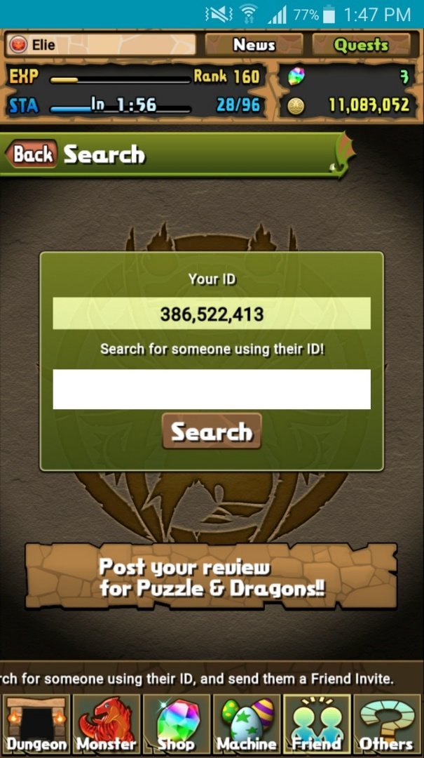

Figure : Player ID search

From the Friend option, players may interact with other players by sending invitations to others and register them as friends by sharing player IDs. Players can then choose to send messages to their friends and best friends.

#### Other

From the Others option, players have access to a wide range of options concerning the functions of the application, links to external sources, services about the game, information about Gungho, options to change certain settings, etc.

#### Quests

Found on the top right corner, players have access to quests. These offer rewards to players once specific conditions are met. Each quest is classified within categories and state the specific request needed to obtain the reward associated to a given quest.

#### News

On the top corner of the window, next to the quests option, players have access to a news section to view the latest information on the daily activities of Puzzles and Dragons and/or any changes and updates done to the application. All these are composed by Gungho.



Figure : Game Navigator

#### Game Navigation

Puzzles and Dragons uses a Simple Category Style Navigation breaking up Into Individual Subjects. Starting the Game Brings you to the Title Screen which allows you to start the game or access Data Restoration. Once inside the game the categories are listed at the bottom excluding News and Quest, which are located in the top right of the screen. The Navigation Menu is accessible through the game, except while in a dungeon, Pulling and Egg machine, or Composing a Message.



Figure : Game Navigation Bar

### Player



Figure : Information Banner and Player ID

The Representation of the entity playing Puzzles and Dragons, it holds all information related to the specific user, it consists of the following Elements:

#### Player Identification

Players are uniquely Identified with the Player ID. Located at the top left corner of the start screen, it is comprised of 9 digits generated automatically and is unique among all players worldwide.

Players can also be identified with a Player Name, located at the top left corner of the information banner, this is chosen by the player and is not unique, it is mainly a cosmetic feature.

#### Player Ranking

Players allocate Experience during gameplay by completing dungeons, displayed in the information banner as a “EXP”. Allocating the preallotted amount of Experience will increase a Players Rank.

A Players Rank is used to Determine the game content accessible by the player, as well as increasing the Max Team Cost, Max Stamina, Max Friends, and the number of Teams a Player has. These increases are predetermined by rank. Increasing rank will also refill your Stamina.

#### Player Stamina

The Players Stamina is used to enter a dungeon. It is located in the information banner as “STA” on the bottom left. Stamina Regenerates at a rate of 1 per 3 mins, but will not regenerate more than the Maximum Stamina. Stamina can be purchased via a Magic Stone which will grant you an amount of Stamina equal to your Maximum Stamina, adding it to your current stamina; It can exceed your Maximum Stamina as Excess Stamina.

#### Player Currencies

Currencies are acquired through dungeon completion, selling of monster, playing with friends and helpers, and with microtransactions. Your Coins and Magic stones are displayed in the top right of the information banner. Pal points are displayed at the Pal Egg Machine and Monster Points are displayed on the Monster Point Store Button in Shop.

#### Player Monster Collection



Figure : Monster box

Players collect Monster Cards that are stored in the Players “Monster Box”. The amount of Monster Cards a Player can store, are listed in the bottom right corner of the “Monster Box”. This amount is increase on specific Ranks, but can also be increase via the “Increase Capacity” using a magic stone.

Players can create Teams of Monster Cards. Each team is comprised of 1-5 Monster Cards, but must have a total Team Cost less or equal to the Max Team Cost a Player has. Each Team can be equipped a Badge once the Player has completed their first quest.

Monster Cards collected and Monsters encountered in dungeons are added to the players “Monster Book”. All Monster IDs are listed with Question Mark Icons, Once Encountered in a dungeon the Monster Cards Thumbnail is displayed slightly transparent, if the Monster Card is collected the thumbnail is Opaque.

#### Player Friends

Players can invite another Player to be their friend after using one of their Monsters as a Helper, or inviting them directly by searching for their Player ID. Having a Player as a friend frequently lists their Monsters as Helpers.

#### Player Time Groups

|  |  |
| --- | --- |
| Time Group | Digit |
| A | 0,5 |
| B | 1,6 |
| C | 2,7 |
| D | 3,8 |
| E | 4,9 |

Players are placed in Time Groups for special event timings to alleviate demand on servers. The third digit of a Players ID identifies what Time Group they are part of. There are also Starter Groups based on the Starting Attribute the player has. The Starting Attribute is located to the Left of the Player Name in the information Banner and is based on the Monster a player picks to start with.

### Monster

Monsters are collectible characters found in Puzzles and Dragons. They serve as a player’s protagonists as well as the antagonists. Each monster is defined by numerable properties, some are commonly shared among all monsters while others are unique to specific monsters. By collecting, enhancing and evolving monsters, players increase their chances of survival when confronting the monsters found in dungeons. Monsters are also known as Monster Cards. This term.

#### Monster Identification

Each monster is uniquely represented by a numeric known as the Monster Number ID and by and Alphanumeric continuation known as the monster’s name. These two properties help identify and uniquely represent each monster found in Puzzles and Dragons.

#### Rarity

Each monster has a value represented by stars. This helps players determines how valuable a monster can be and how common it may be.

#### Attribute

Attributes are the property of a monster that determines the type of damage a monster will deal in a dungeon. A monster can currently have up to two (minimum of one) of five attributes consisting of:

|  |  |
| --- | --- |
|  | Fire |
|  | Water |
|  | Wood |
|  | Light |
|  | Dark |

Figure : Monster Attribute Table

#### Types

A classification of a monster. A monster can currently have up to three (minimum of one) of (currently) twelve types.

|  |  |
| --- | --- |
|  | God |
|  | Devil |
|  | Machine |
|  | Healer |
|  | Dragon |
|  | Physical |
|  | Attacker |
|  | Balanced |
|  | Evo Material |
|  | Enhance Material |
|  | Awaken Material |
|  | Redeemable Material |

Figure : Monster Type Table

#### Skills

Figure : Leader Skill & Active Skill



##### Skill:

A modifier belonging to monsters that can be used in dungeons to modify the board, the player’s team or the enemies. Active skills are used within dungeons by the player. They have three main pieces to them. The effect, the level of the skill, and its cooldown.

The effect is a modifier that may change the board, the players monsters, or the enemy monsters.

The level is the current level the skill is at. Leveling up a skill will reduce its cooldown by one turn. Skills have a maximum level.

The cooldown is the number of turns a player must take within a dungeon before they are able to use the active skill.

##### Leader Skill:

A passive in-dungeon modifier granted to the player based on the leader monster. This may modify the board, the player’s team or the enemies. Also, upon meeting certain requirements, additional bonuses will be added during dungeon play. Not all monsters have a leader skill. Effects from multiple leader skills multiply.

##### Awoken Skill:

Awoken skills are passive skills that are activated upon fulfilling certain requirements within a dungeon.

Monster may have no awoken skills or several.

Awoken skills are not initially active.

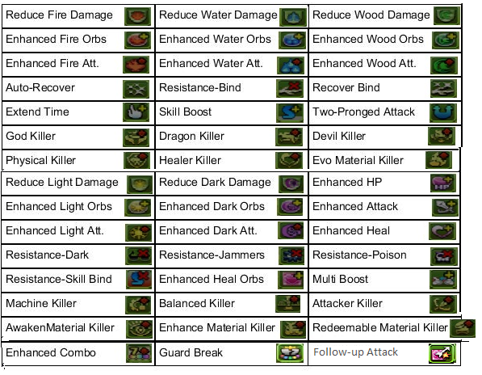

Figure : Awoken Skill Table

##### Latent Awoken Skill:

Latent Awoken skills are the same as awoken skills, however monsters may only (currently) have a maximum of six. Unlike Awoken Skills, Latent skills are added to a monster by the player through Power-Up Fusion. Not all monsters are able to use all latent skills.

|  |  |
| --- | --- |
| No.3323 Latent TAMADRA (Attacker Killer) | Attacker Killer |
| No.2210 Latent TAMADRA (Auto-Heal) | Auto-Heal |
| No.3322 Latent TAMADRA (Balanced Killer) | Balanced Killer |
| No.2216 Latent TAMADRA (Dark Dmg. Red.) | Dark Damage Reduction |
| No.3320 Latent TAMADRA (Devil Killer) | Devil Killer |
| No.3319 Latent TAMADRA (Dragon Killer) | Dragon Killer |
| No.2211 Latent TAMADRA (Ext. Move Time) | Extend Move Time |
| No.2212 Latent TAMADRA (Fire Dmg. Red.) | Fire Damage Reduction |
| No.3318 Latent TAMADRA (God Killer) | God Killer |
| No.3325 Latent TAMADRA (Healer Killer) | Healer Killer |
| No.3317 Latent TAMADRA (Imp. All Stats) | Improve All Stats |
| No.2208 Latent TAMADRA (Imp. ATK) | Improved Attack |
| No.2209 Latent TAMADRA (Imp. RCV) | Improved Healing |
| No.2207 Latent TAMADRA (Imp. HP) | Improved HP |
| No.2215 Latent TAMADRA (Light Dmg. Red.) | Light Damage Reduction |
| No.3321 Latent TAMADRA (Machine Killer) | Machine Killer |
| No.3324 Latent TAMADRA (Physical Killer) | Physical Killer |
| No.2425 Latent TAMADRA (Skill Delay Resist.) | Skill Delay Resist |
| No.2213 Latent TAMADRA (Water Dmg. Red.) | Water Damage Reduction |
| No.2214 Latent TAMADRA (Wood Dmg. Red.) | Wood Damage Reduction |

Figure : Latent Awoken Skill Table

#### Monster Experience and Leveling

The overall strength of a Monster can be increased by increasing the amount of Experience through the process of Power-up Fusion, which in turn increases the Level of the monster and the values of the Base Stats of the monster. At 0 Experience a Monster will be level 1.

Each monster has an Experience Curve which sets the required Experience to reach each new level. The Experience curves generally used are:



Figure : Chart of Experience Curves

* 1,000,000
* 1,500,000
* 2,000,000
* 3,000,000
* 4,000,000
* 5,000,000
* 6,000,000
* 8,000,000
* 10,000,000
* 16,000,000

The Maximum Level of a Monster is predetermined by design, and is used in unison with the Experience Curve to determine the Maximum Experience a Monster can obtain. Depending on the Maximum level the Maximum Experience can be ranged from 0 to the Experience Curve Value.

#### Monster Stats

Each Monster has Stats for:



Figure : Monster Card

* Health Points (HP) – The Amount of Health a Monster will add to a Team.
* Attack (ATK) – The Amount Attack power that will be used with Attributes to calculate Team ATK.
* Recovery (RCV) – The Amount of Recovery that will be added to a Team, used for Healing Health Points.

Each Stat is Given a Minimum Value and Maximum Value for Level 1 and Maximum Level respectively. Each Stat also has a Growth Rate; There are 3 different Growth Rates used:

* Early Bloomer – Stats are increased quicker at early levels and give less gain as the monster approaches Maximum Level.
* Normal – Each level increases the Stat value by the same amount.
* Late Bloomer – Stats are increased slowly at early levels but increase gain as the monster approaches Maximum Level.

##### Monster Bonus Stats

In Addition to the Base Stat values the total stats of the monster can be increased in 4 different ways:

* Plus (+) Stats – Plus Stats are permanently added to a Monster through Power-Up fusion with Monsters who have Plus Stats, increasing only the Plus Stats on Matching Stats. They are color coded Yellow in the Monster Information Section. Each Stat can have a total of 99 Plus Stats for a Grand total of 297. The Gains of Plus Stats are different for each Stat:



Figure : Monster Assist

* + - HP Gains 10 HP for Each Plus Stat for a total of 990
    - ATK Gains 5 ATK for Each Plus Stat for a total of 495
    - RCV Gains 3 RCV for Each Plus Stat for a total of 297
* Assist Bonus – Color coded Blue in the Monster Information Section, having a monster assistant equipped of the same Primary Element will grant bonus Stats of:
  + - HP – Will be granted 10% of the monster assistants Base HP
    - ATK – Will be granted 5% of the monster assistants Base ATK
    - RCV – Will be granted 15% of the monster assistants Base RCV
* Awoken Skills – Some Awoken Skills have the effect of increasing base stats a small percentage or set amount.
* Latent Awoken Skills – Some Latent Awoken Skills have the effect of increasing base stats a small percentage or set amount.

#### Power-Up Fusion

Using Power-up Fusion will let your monster gain experience by consuming other monsters. The base monster gains experience based upon the monsters that were used in the fusion and the monsters used are destroyed. This is the only way to level up monsters in the game.

**Skill Up:** Upon preforming a fusion upon a monster with another monster(s) will the same Active Skill or a Pi with the same primary attribute there is a chance for the skill to level up.

**+ Fusion:** Upon preforming a fusion upon a monster using a monster that has + stats, the + stats will be transferred to the base monster.

**Awakening:** For an awoken skill to become active, a monster must be powered up using a monster of the same class or a Tamadra.

Figure : Power-Up Fusion

#### Evolution

Figure Evo Tree

A monster is able to be changed into another class of monster when certain requirements are met. This is monster evolution.

These requirements include:

* Specified Level (of base monster)
* Monsters required in evolution\*
* Coins

\*Anywhere from one to several monsters will be fused into the base monster and destroyed upon evolution.

Upon evolution, numerous changes will occur:

* The monster ID and name will change.
* The active skill, leader skill, and awoken skills of a monster are subject to change upon evolution.
* The HP, RCV, and ATK of a monster may change upon evolution. Most monster’s stats will change, however not all do so.

##### Evolution Types:

**Evo Fusion:**

* Upon performing this evolution, the monster’s level will be set to 1 and the evolution is not reversible.
* The prerequisites for this type of evolution are that a monster must be Max Level.

**Ultimate Evolution:**



Figure : Evolution

* Ultimate evolution is a form of evolution in which a monster will change into another form with the ability to change back to the previous form.
* Upon performing this evolution, the monster’s level will not be set to 1. Instead, the monster retains its current level and gain experience from the monsters used to evolve it.
* Ultimate evolutions are reversible and the monster does not need to be max level to preform this type of evolution.

**Devolution:**

* Devolution is the process of converting a monster to a previous form within it’s evolution tree.
* Devolution is only possible if the monster is an Ultimate evolution.

**Reincarnation:**

* Reincarnated evolution follows the same rules as evo fusion.
* Upon preforming this evolution, the monster’s level will be set to 1 and the evolution is not reversible.
* The prerequisites for this type of evolution are that a monster must be Max Level.



Figure : Monster info

#### Assists (Rank required is 130)

The monster chosen for an assist is known as the “Base Monster” and the monster chosen for assist is known as the “Assist Monster”. The concept of assisting monsters is to merge one monster with another so the Base monster will benefit by receiving potential properties from the Assist monster.

Assist requirements

* Any monster with a skill can be used as a Base Monster
* Assists are only available once a player reaches rank 130
* Only specific Monsters can be selected as an Assistant
* Only monster whom has all awoken skills awoken and is represented with a golden star icon on the monster’s profile in the monster box can be selected to be an assist.

Assist benefits

* If the Base Monster and the Assist Monster share the same Main Attribute, the Base Monster will receive a bonus to their stats represented as Blue +stats.
* The Base Monster will inherit the Assist Monster’s Active Skill. When gameplay, the player will have access an Assist Monster’s Active Skill through the Base Monster associate.
* Assisted monsters will have the secondary Active Skill displayed bellow the primary Active Skill.



Figure : Edit Team

#### Teams

Teams are a group of a player’s monsters that are used to battle within dungeons. Teams are comprised of a team name, a leader monster, zero to for sub-monsters, and an Awoken Badge.



Figure : Team Name Change

**Team Name:**

The team name is a small description of the team you are using. It is pre-set to a value and may be changed by the player.

**Team Stats:**

Team stats are split into these following sections:

|  |  |
| --- | --- |
|  | Fire ATK |
|  | Water ATK |
|  | Wood ATK |
|  | Light ATK |
|  | Dark ATK |
|  | Team RCV |
|  | Team HP |
|  | Team Cost |

Figure : Team Stats Table

The individual attack sections are all calculated using the cumulative ATK of the monsters in the team with that attribute. The Team HP is the cumulative HP of all monsters within the team and the RCV is the total RCV of all monsters in the team.

**Leader Monster:**

* The leader monster is the only mandatory monster within a team. When entering a dungeon, only the leader monster’s leader skill will be active.

**Sub-monsters:**

* A player is able to have anywhere from no sub-monsters to four of them. These monster’s stats are added to the total ATK, RCV, and HP of the team.

**Total Cost**

Teams have a stat called Total Cost based upon their rank and awoken badge. This stat is a limitation that prevents certain teams from entering dungeons. Every monster has a cost stat based on a predetermined value for that monster. The cost of all the monsters is added together and if it exceeds the total cost then that team is unable to enter a dungeon.

**Awoken Badge**



Figure : Awoken Badge

Each team may be assigned one awoken badge that will act as a modifier for the team. Badges may change to total ATK, RCV, HP, and/or Team Cost of a team. Only team cost badges are active in multiplayer mode.

A list of badges:

|  |  |
| --- | --- |
|  | Team Cost +100 |
|  | Move Time +1 second |
|  | Mass Attack |
|  | Team RCV +25% |
|  | Team HP +5% |
|  | Team ATK +5% |
|  | Skillboost |
|  | Leaders Bind immune |
|  | Team HP +15% / Team Cost -300 |
|  | Move Time +2 seconds / Team Cost -400 |
|  | Team RCV +35% / Team Cost -300 |
|  | No Skyfall Combos |
|  | Team ATK +15% / Team Cost -300 |

Figure : Awoken Skill Badges Table

**Team Status**

Each of these three symbols correlates to a team. (See Figure 15)

|  |  |
| --- | --- |
|  | Circle: Team 1 |
|  | Square: Currently selected team |
|  | Triangle: Team 2 |

Figure : Team Status Symbols Table

### C:\Users\kyleg\AppData\Local\Microsoft\Windows\INetCache\Content.Word\Dungeons_Menu_Screenshot.pngDungeons

Dungeons are a feature within the Puzzles and Dragons video game in which players use teams of monsters to fight other monsters. A dungeon is comprised of one or more floors, each of which contains one or more monsters that must be defeated to proceed to the next floor. Upon defeating all the monsters within a dungeon, the user will obtain rewards.

Figure : Dungeons Menu

#### Dungeon Navigation



Figure 30: Dungeon Navigation

Following the same Category Style, once in the Dungeon Section you are presented with the Categories of dungeons available, and also Multiplayer mode. Selecting a Dungeon category brings you to the Dungeon Select Screen, after selecting a dungeon you are then presented with the sub dungeons list for that dungeon. Before entering the dungeon, you are given the chance to select a helper, or activate Challenge mode at the bottom of the list of helpers.

#### Dungeon and Sub-Dungeons

Dungeons consist of sub-dungeon(s) that can be cleared to obtain magic stones.

Figure : Dungeon of Fire

Clearing all brown colored sub-dungeons within a dungeon will grant a magic stone.

* Clearing all non-brown colored sub-dungeons within a dungeon will grant a magic stone.
* Clearing all sub-dungeons within a dungeon will grant that dungeon a cleared status.

Figure : Dungeon of Fire Sub-Dungeons

#### Normal Dungeons

* A series of dungeon in which dungeons are cleared in a specific order.
* When one dungeon is cleared the next one will be unlocked for a player to play.
* In certain cases, clearing a dungeon will unlock multiple dungeons or no dungeons.

#### Technical Dungeons

* Available after clearing Castle of Satan in Normal Dungeons.
* Clearing and unlocking dungeons works in the same manner as Normal Dungeons
* Clearing Castle of Satan in the Abyss will unlock a dungeon mode called challenge mode.
* Challenge Mode Dungeons are Normal and Technical dungeons may be cleared in Challenge mode for an extra stone after they have been cleared once.

#### Special Dungeons



Figure : Special Dungeon Menu

* Daily Dungeons (Dungeons are available based on the day of the week)
* Descended Dungeons
* One-Time Dungeons (only available before it is cleared for the first time)
* Reward Dungeons (rewards are only given for first time clears)
* Event Dungeons (Dungeons available for a limited time during events)
* Coin Dungeons
  + Coin Dungeons are available for a limited time in the multiplayer section after purchase in shop.
  + Coin dungeons with the same names as other dungeons do not share their clear status.

#### Multiplayer Dungeons

* Available upon reaching rank 30
* Available in 2-player mode and 3-player mode.



Figure : Multiplayer Modes

* 2-player mode allows two players to enter a dungeon together. The leader monsters are shared and the subs are switched each turn. The health pool is shared by both players.
* 3-player mode allows 2 – 3 players to enter a dungeon together. In this mode players choose their friend leaders and do not share any stats with each other.
* Dungeons share cleared status with dungeons from other categories.
* Dungeons from other categories such as Special Dungeons (except reward dungeons) and technical dungeon are available in 2-player mode.
* Technical Dungeons
  + Clearing a Technical dungeon in multiplayer will unlock it for a player and mark the dungeon as cleared if it has not yet been unlocked or cleared for that player.

#### Ranking Dungeons

* Available upon reaching rank 150
* All players are ranked based on the points they obtain while the dungeon is available, out of all the players that cleared the dungeon.

#### Dungeon Entrance



Figure : Dungeon Entrance

All dungeons have specific requirements that must be met before entering. Each dungeon has a stamina cost a player must pay to enter as well as the possibility to have one or more requirements. These requirements include but are not limited to:

* No duplicate monsters (except helper)
* All Attributes Required
* Specified monster required to be on the entering team
* No more than a specified number of monsters on team

In addition to the entrance requirements, dungeons may also have global modifiers placed upon them. These modifiers include but are not limited to:

* Board size modifiers
* Orb types appearance modifiers
* Assists invalid
* Awoken Skills Invalid
* Leader Skills Invalid
* Type Enhanced (1.5x monster stat multiplier)
* Attribute Enhanced (1.5x monster stat multiplier)
* No Continues
* Fixed Team
* Fixed Orb Movement Time
* No Skyfall orbs (orbs do not fall until your turn is finished)
* Stamina modifiers
* Drop rate modifiers
* Experience modifiers

You are able to bring in a helper monster (one of your friend’s monsters) to assist you in the dungeon.

Your leader monster, as well as your helpers’ monster leader skill will be active (unless dungeon modifiers specify otherwise).

#### Single Player Dungeon Gameplay

TBD

Continues: You are able to continue playing a dungeon for the price of a magic stone if you lose (unless otherwise specified).

* 4 seconds base move time + Awoken/Latent Awoken Skill bonuses (unless otherwise specified).

#### Multiplayer Mode (Rank required is 10)

**Description**

Puzzles and Dragons offers a multiplayer mode where 2 to 3 players can join forces and tackle dungeons together. Certain multiplayer options will result in the Stamina cost for entering a dungeon to be diminished for the collaborating players.

**2-Player Mode**

Multiplayer Dungeons for 2 players.

* Create a Room (Room ID)



Figure : Input Room ID

* + 2-Player mode demands that one player creates a Room by selecting from the list of available Special Dungeons. Next, they wait for another player to join the Room. Once the Room is created, and while waiting for other players, the player may copy the newly generated Room ID or share the Room ID to all the player’s registered friends or to specific friend(s). This will send a notification to the player’s friends in the Mail / Invites section under Friend.
  + When All players are ready, the group proceeds to the gameplay.
* Enter a Room ID
  + Here, the player may input an existing Room ID they have acquired via a friend’s invitation or other means.
* Find a Friend’s Room
  + If the player’s friend has created a Room, other players may view that Room in this section. Furthermore, a player may press the available Room and ask to participate with the Room’s creator in their endeavors.

**3-Player Mode**



Figure : 3-Player dungeon menu

Multiplayer dungeons for 2 or 3 players.

* Search for a Partners (Auto-Match)
  + This option allows a player to Create a Room by Selecting a dungeon from the Multiplayer dungeon list and selecting their helper monster. Next, the player’s Room will automatically wait for other players from around the world to join them and proceed to the gameplay with the matched partner(s).
* Create a 2-Player Room (Room ID)
* This option allows a player to Create a Room for him and one more player to join. They will select from a list of the available Multiplayer Dungeons. Next, they wait for another player to join the Room. Once the Room is created, and while waiting for other players, the player may copy the newly generated Room ID or share the Room ID to all the player’s registered friends or to specific friend(s). This will send a notification to the player’s friends in the Mail / Invites section under Friend.
* All players are ready, the group proceeds to the gameplay.
* Create a 3-Player Room (Room ID)
  + This option allows a player to Create a Room for him and two more players to join. They will select from a list of the available Multiplayer Dungeons. Next, they wait for two other players to join the Room. Once the Room is created, and while waiting for other players, the player may copy the newly generated Room ID or share the Room ID to all the player’s registered friends or to specific friend(s). This will send a notification to the player’s friends in the Mail / Invites section under Friend.



Figure : Created Room

* + All players are ready, the group proceeds to the gameplay.
* Enter a Room ID
  + First, the player is asked to select a Helper Monster from their list.
  + Next, the player may input an existing Room ID they have acquired via a friend’s invitation or other means.
* Search for a Room
  + First, the player is asked to select a Helper Monster from their list.
  + Next, the player may select to join an existing Room from other players across the world.

**Game Mechanics**

* During the gameplay, each player only has access to their respective monster’s Active Skills with the exception of the team member’s Leader Monster’s Active Skill.
* The Team’s HP stat is comprised of the sum of each player’s collective HP stat from their individual teams.
* If the group’s HP reaches zero, (signaling a game over) the player who’s turn fell on the game over will have 30 seconds to use a Magic Stone in order to continue playing or the player may choose to quit the dungeon.
* In the case of a game over, players will not be able to purchase Magic Stones in multiplayer mode.

#### Dungeon Completion

**Dungeon Rewards:**

Upon clearing a dungeon, a player will receive rewards. These rewards include player experience, coins, magic stones, pal points, monster points, and monsters that you defeated within the dungeon. All of these rewards are available after each time a dungeon is cleared except magic stones which are only available for first time clears. Not all monsters are obtainable even if they are found within a dungeon and the monsters that are obtainable from a dungeon may be a different evolution than the one defeated within the dungeon.

Clearing certain dungeons will result in a reward that will be sent to the in-game mail system.

### Quests



Figure : Quest Screen

Quests are goals for the player to do that give out a reward upon completion, these quests are cordoned off into 3 groups Degree of Difficulty, Descended, and Maniacs with each of these 3 groups getting progressively harder as you move on.

#### Degree of Difficulty

Degree of difficulty quests are early or lower level quests that introduce players to the idea of completing challenges for rewards. Each section is named in the same scheme as the different dungeon difficulties. Each level of this rewards you with an awoken badge that you can apply to your teams. Each section of difficulty has a series of quests within pertaining to the difficulty.

* Novice
  + Rewards Awoken Badge “Team Cost +100”
* Int
  + Rewards Awoken Badge “Move time +1 second”
* Expert
  + Rewards Awoken Badge “Mass Attack”
* Master
  + Rewards Awoken Badge “Team RCV +25%”
* Legend
  + Rewards Awoken Badge “Team HP +5%”
* Mythical



Figure : Degree of Difficulty

* + Rewards Awoken Badge “Team ATK +5%”
* Legend+
  + Rewards Awoken Badge “Skillboost”
* Mythical+
  + Rewards Awoken Badge “Leaders bind immune”
* Annihilation
  + Rewards Awoken Badge “Skill bind resists +50%”

Some of the sub-quests you can expect to see would be: completing a set number of normal dungeons, completing a set number of technical dungeons, completing a certain difficulty of weekly dungeons, expanding monster box space, unlocking monsters in the monster book, completing a dungeon in Multiplayer, getting a certain rank during a ranking dungeon

#### Descended

Descended quests provide the user with a higher-level challenge having them beat descended dungeons, these descended dungeons are intended to be quite challenging. These dungeons do not need to be beaten in any specific order they can be completed in whichever order you desire.

* Ultimate Hera
  + Beat the different Hera dungeons
  + Rewards Dungeon “Ultimate Hera Rush!”
* Ultimate Zeus
  + Beat the different Zeus dungeon
  + Rewards Dungeon “Ultimate Zeus Rush!”
* Ultimate Devil
  + Beat the different Devil dungeons
  + Rewards Dungeon “Ultimate Devil Rush!”
* Super-Ultimate Dragon
  + Beat the following dungeons
    - “Legendary Seaway-No RCV”
    - “Legendary Mountain Path”
    - “Legendary Hills”
    - “Legendary Skyway”
    - “Legendary Snowy Valley”
  + Rewards Dungeon “Super-Ultimate Dragon Rush!”
* Ultimate Yamato
  + Beat the following dungeons
    - “The Thief Descended”
    - “Wadatsumi - Awoken Skills Invalid”
    - “Kaguya-Hime! - No RCV/Awoken Skill”
    - “Izanami Descended”
    - “Great Tengu Descended – Balanced Enhanced”
  + Rewards Dungeon “Ultimate Yamato Rush!”
* Special Descended
  + Complete Descended dungeons that are Legend+ and Mythical+
  + Rewards Dungeons “Special Descended Rush!”

#### Maniacs

Maniacs quests are the most difficult quests in the game usually pertaining to end game or incredibly advanced content targeted to highly experienced players. These quests have no set order of completion.

* Completed Special Dungeons
  + Beat a set number of special dungeons
  + Rewards Awoken Badge “Team HP +15% / Team Cost – 300”
* Total Monsters in Monster Book
  + Discover a set number of monsters in your monster book
  + Rewards Awoken Badge “Move time +2 seconds / Team Cost – 400”
* Total +297 Monsters
  + Raise a set number of monsters in your collection to +297 stat bonuses
  + Rewards Awoken Badge “Team RCV +35% / Team Cost -300”
* Total Crowns
  + Acquire a set number of crowns (crowns are obtained from ranking dungeons)
  + Rewards Awoken Badge “No Skyfall Combos”
* Total Awoken Skills
  + Have a set amount of awoken skills on monsters in your collection
  + Rewards Awoken Badge “Team ATK +15% / Team Cost – 300”

#### Quest Rewards

Each quest has its own reward for completion these vary based upon quest difficulty and type some examples of these include:

* Coins
* Pal Points
* Magic Stones
* Monsters
* Dungeons
* Awoken Badge

### Mail System

The mailing system in Puzzle and Dragons is an in-game notification system that is used to send and receive messages and notifications. These notifications are sent by the two following sources:

* Player Mail
  + Players can send you personal messages
  + Players can send you friend invites
  + Players can add you as a best friend (sends you a notification of best friend status)
  + Players can send you gifts (each player receives one gift that they can send to someone)
  + Player mail is the only mail you can reply to
  + Delete – Removes this mail from your inbox
  + Ok – Returns you to the previous screen
  + Reply – This allows you to send a response to the player’s message directly from the message mail
* System mail
  + System mail is displayed as being sent by “Game Admin”
  + You cannot reply to this mail
  + This mail may be of the following types: Event gifts, Quest rewards, Dungeon rewards, or Major news updates

Mail may come in the following types:

* Quest Rewards – An item received for completing a quest
  + May contain: Dungeons, Coins, Pal points, Monsters, etc.
* Dungeon rewards – An item received for completing specific dungeons
  + May Contain: Monsters, Coins, Magic Stones, Monster Points, etc.
* Friend Gifts – A present sent to you by a friend that contains a present egg machine
  + Contains an egg machine that may give otherwise unobtainable monsters
* Event Gifts – A present given by the creators of the game during certain events
  + Could be: A monster, coins, a magic stone, monster points, etc.
* Friend Invites – Requests from other players for your friendship
* Friend Messages – A piece of mail that another player has written and sent to you
* Best Friend Notification – A mail message telling that a player has added you as a best friend

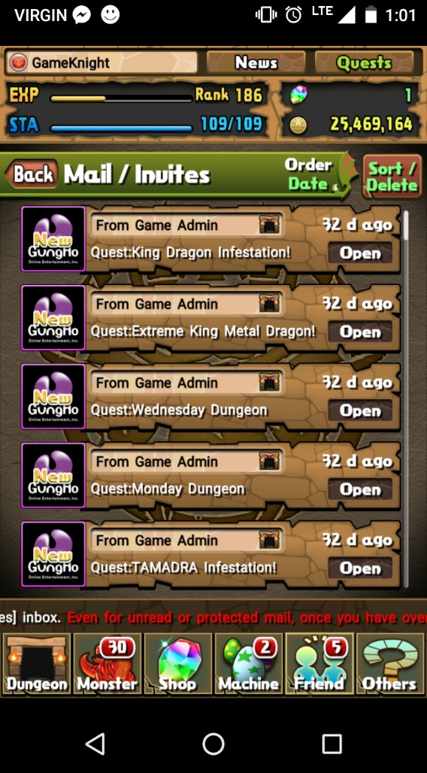

Figure : Mail Screen

#### Mail Screen

Upon opening their mailbox, a player will see messages and invites that have been sent to them either by “Game Admin” or another player

* Tapping on “Open” will allow you to view the contents of the mail

#### Mail

Mail is a message sent to a player for various reasons whether it be for an event by Gungho

Figure : A Piece of Mail

* OK – Confirmation of mail having been read
* Delete- Removes this mail from your mailbox
* Protect – Opts this mail out of “Delete All Read Mail” feature

#### Dungeon Mail

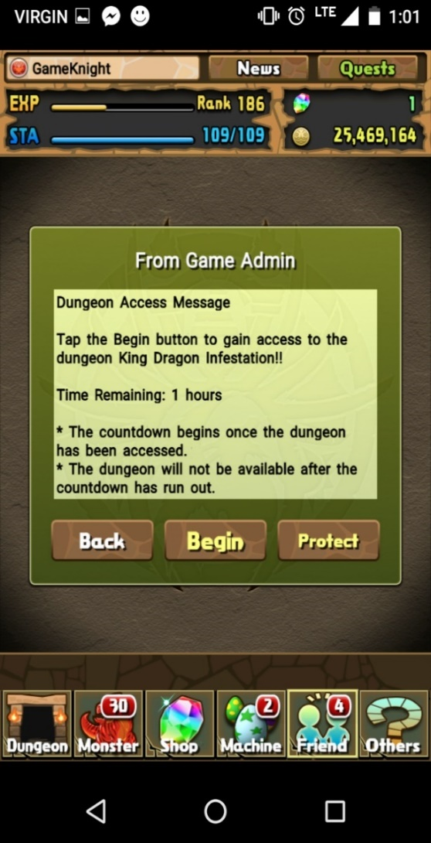

Figure : Dungeon Mail

For completing certain activities or as a gift from Gungho you may receive

* Begin – This activates the dungeon for use
* Back – Returns you to the previous screen
* Protect – Opt this mail out of “Delete all read mail”



Figure : Mail Sorting Options/ Deletion

#### Mail Sorting / Deleting

These are the various options and ways you can sort mail as well as where you can delete all mail simultaneously with one exception to that being protect where the player can choose for a piece of read mail to not be deleted upon a using “Delete all read mail”

* Date – Sorts mail by date received in descending order
* Type – Sorts mail by the different things they contain
* Time Left – Sorts mail based on time before expiry
* Invites – Sorts mail by all the friend invites in your mail including best friend notifications
* Mail – Sorts by friend messages you’ve received
* Egg Machine – Sorts mail by the egg machines you’ve
* Magic Stones – Sorts mail by magic stones you’ve
* Coins – Sorts mail by coins received
* Pal Points – Sorts mail by Pal points received
* Monsters – Sorts mail by monsters received
* Dungeon – Sorts mail by dungeons received
* Monster Pts – Sorts mail by monster points received



Figure : Mail Expiry

#### Mail Expiry

Every unclaimed piece of mail which contains claimable items has an expiry date which after it goes to zero makes the mail unclaimable therefore destroying whichever item(s) were contained within

### Friends



Figure : Friend Menu Navigation

Friends are players that have either accept a friend request from you or that you have accepted friend requests from. You can use their leaders as helpers in dungeons to get bonuses.

#### Gaining Friends

* Accepting a friend request
* Sending a friend request to a non-friend helper
* Sending a friend request to a specific player ID

#### Friend Types

* Non-Friends
  + Players not on your Friend List
  + Labeled as User in Select a Helper screen
  + Given a chance to send a friend request after successfully completing a dungeon using their leader as a helper

Figure : Select a Helper Screen

* + Can only access their current leader
* Friends
  + Players found in Friend List
  + Labeled as Friend in Select a Helper screen
  + Can access their first and current leader and vice versa
  + Can only use each leader once every time they log in
  + Friend must log in daily for their leaders to be selectable
* Best Friends
  + Listed as best friend in Friend List
  + Labeled as Best Friend in Select a Helper screen
  + Can access their first, second, and current leader and vice versa
  + Unlocks a best friend selection at rank 50
  + Best friend status’ are two ways, meaning if one friend upgrades a friend to a best friend, both player have the best friend status for each other
  + Friend must log in daily for their leaders to be selectable
  + Best friend’s leaders are available all day no matter how many times they are used so long as the best friend has logged in within the day

**Note:** A player can only receive Pal Points from each friend once a day.

#### Friend List

The friend list is used to view all of your current friends with their current team’s leader. Here you can choose to:

Figure : Friend List

* Add to Favorite – Gives a friend a favorite status, preventing you from deleting that friend as well as making them easier to find in both the Friend List and Select a Helper screens
* Check Info – Displays the information of the friend’s current leader
* Delete – Removes that friend from your friend list, does not appear if friend is favorited
* Remove from Fav. – Removes the favorite status from a friend, allowing you to once again delete them from your Friend List (Only appears if that friend is favorited)

**Note:** If a best friend is either deleted or deletes you, they will no longer have a best friend status if they are re-added. You also will not get back the best friend status to place on another friend.

Player starts off with 20 friend slots and gains more while ranking up, up to 50 slots.

Friend slots can be purchased with magic stones, 1 stone unlocks 5 friend slots.

 Not Favorited Favorited

Figure : Friend Options

### Game Currency

Game currencies are in-game monetary values used for a variety of things, such as, Power-Up Fusion, Egg Machines, purchasing monsters and dungeons, and Evolution.

There are many types of currencies:

* Coins
* Pal Points
* Monster Points
* Magic Stones.

#### Ways of Receiving Currencies

There are many different ways to accumulate the varying types of currencies, such as:

Coins

* Successfully completing dungeons
* Rewards from quests
* Rewards from challenge dungeons
* Selling monsters
* Daily login bonus

Pal Points

* Choosing a Helper
* Chosen as a Helper
* Completing a dungeon in multiplayer
* Daily login bonus
* Rewards from quests
* Rewards from challenge dungeons

Monster Points

* Selling a monster provides a set amount of monster points based on the specific monster.
* Completing dungeons in multiplayer
* Rewards from completing certain dungeons

Magic Stones

* Completing Dungeons
* Purchasing them with real life currency
* Rewards from Admins
* Rewards from quests

#### Coins

Figure : Coins and Magic Stones (Right)

Coins are the most common currency in puzzle and dragons.

Coins are used for:

* Power-Up Fusion
* Evolution
* Assists
* Purchasing Coin Dungeons

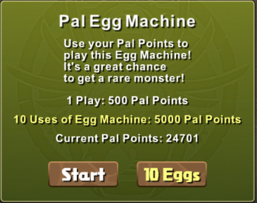

Figure : Pal Points

#### Pal Points

Pal points are used for the Pal Egg Machine.

#### Monster Points

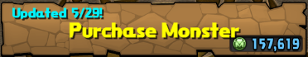Monster points are used to purchase monsters from the Purchase Monster store.

Figure : Monster Points

#### Magic Stones

Magic stones are Puzzle and Dragons’ premium currency. They are used for the more serious purchases in the game.

Magic stones are used for:

* Rare/Event Egg Machines
* Restoring Stamina
* Increasing Monster Box Capacity
* Increasing Friend List Capacity
* Continuing a dungeon you died in



Figure : Shop Menu

### Shops

Shops are where players can purchase things, such as, monsters, dungeons, stamina, monster box upgrades, and friend list upgrades, with in-game currencies.

Currently these are the available shops:

* + Magic Stones Shop (Microtransaction)
  + Purchase Monster
  + Purchase Dungeon with Coins
  + Restore Stamina
  + Increase Capacity
  + Increase Max No. of Friends.

**Note:** In Figure #, Increase Max No. of Friends is slightly lower in the menu.

#### Magic Stone Shop

Figure : Magic Stone Shop

Magic stones are Puzzle and Dragons’ premium currency. They are used for the more serious purchases in the game.

Here a player can purchase the in-game currency, Magic Stones, with real money, this type of transaction is referred to as a microtransaction.

These are the current prices for differing amounts of magic stones (Display is different based on device):

* 1 Magic Stone
* 6 Magic Stones
* 12 Magic Stones
* 30 Magic Stones
* 60 Magic Stones
* 85 Magic Stones

#### Purchase Monster (Rank 60 Req.)

Figure : Purchase Monster

Here a player can purchase certain monsters, using the in-game currency, Monster Points.

Monster included in this shop do change periodically.

Examples of Monsters available:

* Evolution Material
* Enhance Material
* Monster currently unavailable anywhere else in the game

#### Purchase Dungeon with Coins (Rank 80 Req.)

Figure : Purchase Dunegons with Coins

Here a player can (as the name of the shop suggests) purchase dungeons with the in-game currency, coins. There are many different dungeons with differing difficulties and prices currently listed in this shop. After successfully purchasing a dungeon, that dungeon appears in the Special Dungeons and will stay there for 1 hour. You are able to play that dungeon as many times as you want within the time span and you can buy the same dungeon multiple times. You can only have a single dungeon purchased at a time, if you purchase another before the time has runs out the previous dungeon will be replaced with the new one.

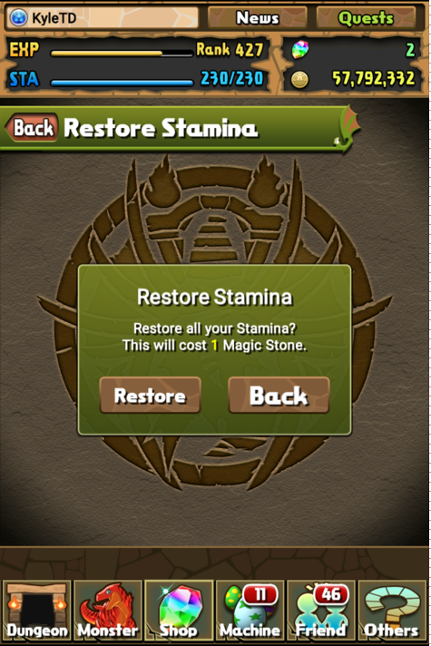

Figure : Restore Stamina

#### Restore Stamina

If a player does not have a full stamina bar then they are able to use the Restore Stamina shop. For a single magic stone the player will receive a one time boost to their stamina (For example: a player has a total stamina of 100, if they restore stamina they will receive 100 stamina). If the restored stamina exceeds the player’s total stamina the excess stamina is placed in a kind of reserve, meaning the player will temporarily have more stamina then their total stamina.

**Note:** Excess stamina does not affect stamina requirements of dungeons. Your total stamina must meet the requirements.

#### Increase Capacity

Figure : Increase Capacity

Here a player can increase the size of their monster for magic stones. Currently there are 2 options, 5 slots for 1 magic stone or 50 slots for 10 magic stones. Increasing the size of a player’s monster box benefits the player as it allows them to store more monsters.

#### Increase Max No. of Friends

Figure : Increase Max No. of Friends

Here a player can increase the size of their friend list by 5 for 1 magic stone. Increasing the size of a player’s friend list benefits the player allows them to add more friends, giving them access to more helpers.

### Egg Machines

Egg machines are a feature found in Puzzle and Dragons that allows users to collect new monsters as well as monsters you may already have. The monsters that appear from this are randomised and usually based on current egg machine modifiers. These monsters appear in 6 different types of eggs that are based on the rarity of the monster contained within.

#### Using Egg Machines

There are 3 types of egg machines currently in Puzzle and Dragons and they are as follows:

* PAL Egg Machine
  + The egg machine that you spend PAL points on to receive monsters
  + Currency – PAL points
  + Current Price – 500 PAL points
* Rare Egg Machine
  + An egg machine that you spend magic stones on to receive monsters
  + Currency – Magic stones
  + Current Price – 5 magic stones
  + Event Egg Machine (this is a type of rare egg machine)
    - Egg machine that pertains to specific events that happen throughout the year
    - Currency – Magic stones
    - Current Prices – 5 or 10 Magic stones

To use these machines, you must have the required currency for the machine you want. After selecting the machine you want, you will be taken to a screen with the egg machine on it, to move from this screen you will hold on the machine’s arm and pull it down (this process is known as “pulling”). After you pull you will see an animation of an egg coming from the machine, the color or pattern will determine the rarity level of the monster. You will then be taken to a screen showing the monster egg being opened followed by a screen which shows the monster’s information and stats.

#### Egg Machine Modifiers

Egg machines are on a rotation that usually changes every week these rotations affect the drop rates of monsters as well as the drop pools (which monsters can drop).

This is the current list of egg machine modifiers

* Events
  + If there is a special limited time event there will be drops based on that event
* Galas
  + There will be periods of time where monsters of certain primary attributes will have a higher chance of dropping
* PAL Rotation
  + The PAL egg machine has a rotation of different monsters that can drop from it ranging from monsters used for evolving to rare monsters
* Bonus Monsters
  + During an egg machine rotation, you may receive an extra monster for using a machine
* Increased rates
  + During an egg machine rotation, certain monsters will drop at an higher rate than normal

#### Event Egg Machine Types

Event egg machines are one of the communities’ favorite egg machines as they can offer unique and rather powerful monsters. These egg machines can come in a few different types

* Holidays
  + Sometimes through the year there will be a holiday egg machine these will drop monsters associated to these holidays
* Series
  + Through the year Gungho will release updates to certain monster series’ that they deem necessary for their own egg machines
* Collaborations
  + On occasion Gungho will team up with another company whether it be a game company or an anime company in order to release monsters from content produced by the partner company for example Final Fantasy Collaboration

#### Machine Navigation



Figure : Machine Menu Navigation

The Machine Menu has few Options, it will list available machines, if you have the currency for the machine, you select the machine and agree with the confirmation. The details menus will show you information on the available machines.

## Requirements Fundamentals

## Practical Considerations

## Requirement Information Items

# Processes

## Requirements Processes

### Navigation

The process of navigation in Puzzle and Dragons is done through a mixture of tapping on your screen and swiping your finger up and down to move through extended screens. There are various buttons used for navigation as well such as the “Back” button on certain screens to return you to the previous screen, or on certain phones there will be a back button on the phones navigation bar near the bottom which works like the back button in-game except this button will allow the player to go to the title screen when they press it on one of the main sections of the game.

Navigate to Dungeons

1. Select “Dungeon”

-Normal Dungeon-

1. Select “Normal Dungeons”

-Technical Dungeon-

2. Select “Technical Dungeons”

-Special Dungeon-

2. Select “Special Dungeons”

Navigate to Monster

1. Select “Monster”

-Edit Team-

2. Select “Edit Team”

-Power-Up Fusion-

2. Select “Power-Up Fusion

-Evolution/Ultimate Evolution-

2. Select “Evolution/Ultimate Evolution”

-Manage Assists-

2. Select “Manage Assists”

-Sell Monsters-

2. Select “Sell Monsters”

-Monster Box-

2. Select “Monster Box”

Navigate to Shop

1. Select “Shop”

-Magic Stone Shop-

2. Select “Magic Stone Shop”

-Purchase Monster-

2. Select “Purchase Monster”

-Purchase Dungeons with Coins-

2. Select “Purchase Dungeons with Coins”

-Restore Stamina-

2. Select “Restore Stamina”

-Increase Capacity-

2. Select “Increase Capacity”

-Increase Max No. of Friends-

2. Select “Increase Max No. of Friends”

Navigate to Machine

1. Select “Machine”

-Pal Egg Machine-

2. Select “Pal Egg Machine”

-Rare Egg Machine-

2. Select “Rare Egg Machine’

Navigate to Friend

1. Select “Friend”

-Friend List-

2. Select “Friend List”

-ID Search-

2. Select “ID Search”

-Mail / Invites-

2. Select “Mail / Invites”

- Send Mail-

2. Select “Send Mail”

Navigate to Monster Book

1. Select “Others”
2. Select “Monster Book”

Navigate to Quests

1. Select “Quests”

-Degree of Difficulty-

2. Select “Degree of Difficulty”

-Descended-

2. Select “Descended

-Maniacs-

2. Select “Maniacs”

### Selling Monsters

1. The player may select the “Manage Assists” option found under “Monster” on the Menu Bar.
2. All monsters can be sold.
   * **Note**: There must be a minimum of one monster in a player’s position at all time. In the event that a player only has one monster, it cannot be sold.
3. Monsters that are labelled under favorites or in-use cannot be selected and sold.
   * **Note:** If a player wishes to sell a monster under these labels, they must first remove them before proceeding.
4. Players may select and sell multiple monsters at once. Selecting a monster will change the monster card to grey and place a numbered icon in the middle.
5. Once a player is ready, they must press the “OK” button.
6. A prompt will appear asking the player if they wish to proceed. Pressing “Yes” will officially sell the monster meaning they will be removed from the player’s roster permanently. This action will give players both Monster Points and Coins when finishing the transaction.
7. If a player presses “No” on the prompt, the transaction is cancelled and the player is returned to his list of monsters.
   * Note: All previously selected monsters will remain selected.
8. Taping on a selected monster will cancel the selection and so, that monster will not be sold.
9. To unselected monsters, players can press the “Clear” button unselect all monsters at once.

### Power-Up Fusion

To perform a Power-Up Fusion:

1. Select “Monster” from the Game Navigation Bar.
2. Select “Power-Up Fusion” from the Monster Menu.
3. Select the Base Monster to perform the Power-Up Fusion on.
4. Select an empty Material Slot, or for multiple selection select “Add Many”.
5. Select the Monster/Monsters to be used as material.
6. Ensure your Coins are greater or equal to “Coins Needed”.
7. Select “Begin Fusion!”
8. If Material has rarity greater you must confirm the Power-Up Fusion.

**Leveling**

Performing Power-Up Fusion on the Monster with material/materials that grant “EXP gained” greater or equal to “To Next Lv.:” value will result in the Monster Leveling up.

**Awakening**

Performing Power-Up Fusion on the Monster with the Awoken Material “Tamadra” or “Baby Tamadra” or with a Monster with identical Monster ID will awaken that Monster. Note that “Baby Tamadra” only has a 50% chance of Awakening.

**Skill-Up a Monster**

|  |  |
| --- | --- |
| Primary Attribute | Py Enhance Material |
| Fire | Flampy |
| Water | Bubpy |
| Wood | Woodpy |
| Light | Shynpy |
| Dark | Badpy |

To Skill-Up your Monsters Active Skill, perform Power-Up on the Monster using the Enhance Material “Flampy, Bubpy, Woodpy, Shynpy, or Badpy” of the corresponding Primary Attribute. If the Monster is an Ultimate Fusion and level 99, Using another Monster of the same Monster ID that is also level 99 as Material will also Skill-Up your Monsters Skill.

Performing Power-Up Fusion with a Monster with the same Active skill will have a 10% chance of granting a Skill-Up.

**Plus Stat (+) Enhancement**

Performing Power-Up Fusion on the Monster with Material that has the Plus Stat will add those Plus Stats to the Monster. Note Plus Stats will only Increase the Stat that the Plus stat is attributed to; Plus ATK will not increase Plus HP vice versa.

**Latent Skill**

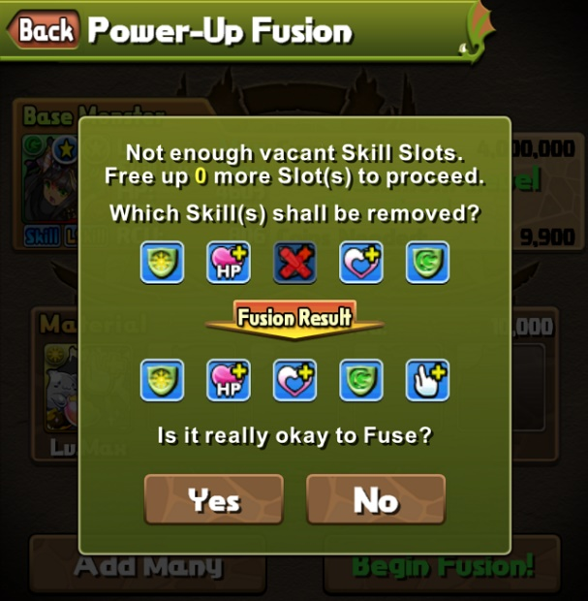

Figure : Latent Skill Replacement

Performing Power-Up Fusion using a “Latent Tamadra” as material will grant any monster (Excluding “Evo Material”) a Latent Awakening Skill corresponding to the “Latent Tamadra” Used as Material. If a Monster is Latent Slots are full, the Player chooses the Latent Awakening Skill that will be Replaced. If “Extra Latent Slot Tamadra” is used as Material, the Monster will gain another Latent slot (Maximum of 6).

### Evolution

To perform an Evolution:

1. Select “Monster” from the Game Navigation Bar.
2. Select “Evolution/Ultimate Evolution” from the Monster Menu
3. Select a Monster with an available evolution. Marked with a Red Blinking Arrow to the right of the Portrait.

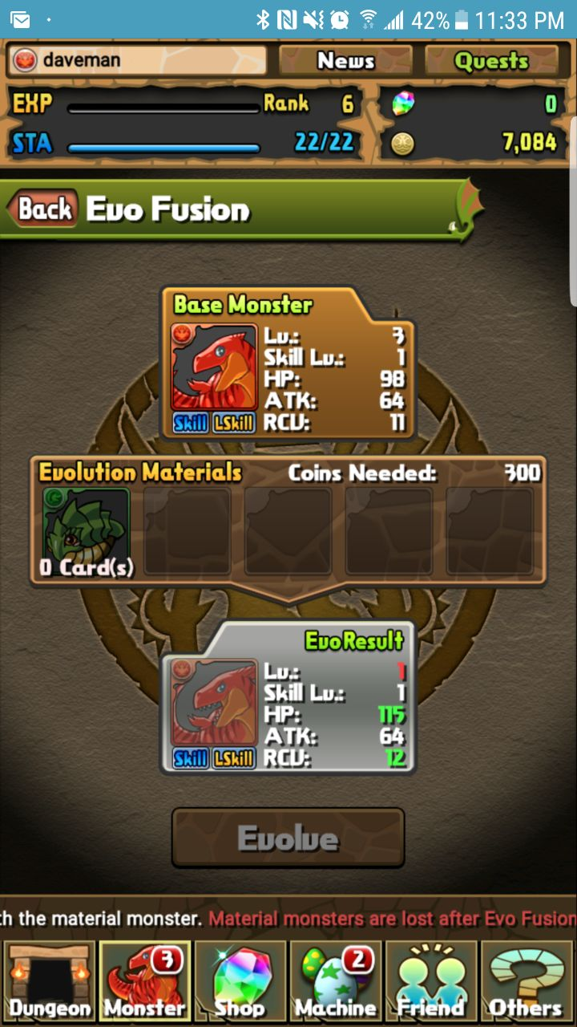- Evo Fusion –

1. Ensure Your Monster is Max Level and you have the needed Materials and Coins.
2. Select “Evolve”

- Ultimate Evolution / Devolution –

1. Select the evolution intended.
2. Ensure you have the need Materials and Coins.
3. Select “Evolve”

- Reincarnation -

1. Selected the Reincarnation
2. Ensure Your Monster is Max Level and you have the needed Materials and Coins.
3. Select “Evolve”

### Assists

#### Assists Process

1. The player may select the “Manage Assists” option found under “Monster” on the Menu Bar.
2. Selecting this option, the player will be sent to a list of their monsters.
3. The monsters available to be used as Base Monster will be fully colored and those who can’t, will be greyed out.
4. Once a monster is selected, a prompt will be displayed instructing the requirements for assistance. Confirming the prompt will send the user to his list of monsters once again.
5. Here, the monsters available to be Assist Monsters will be fully colored and those who can’t will be greyed out.
6. Player can always revert the assist if they wish. Simply, repeat the steps but instead, select the monster whom is already assisted and confirm they wish to undo the assist.

#### Assist Monster Gameplay

1. An Assisted Monster will play exactly the same as any Monster with the exception of the Secondary Skill.
2. The Assist Monster’s Active Skill can only be used after the Base Monster’s Active Skill is charged.
3. Once the Primary Active Skill is Charged, the player may use that Active Skill.
4. The secondary Active Skill Must also be charged in order to be used.
   1. **Note:** The secondary Active Skill does not charge at the same time as the primary Active Skill.
5. If players use the primary Active Skill, the process will restart from the very beginning.

### Edit Team

#### Editing Monsters on a Team

Figure : Editing Leader

First the player selects the monster slot they want to edit. Once a slot is selected, the Select a Monster screen will open. If you are editing the leader slot then you will only be able to select a monster that is not currently on that team, as a team must at least have a leader.

If you are editing one of the sub monster slots an extra option will be available. Remove performs the actions it states, it removes any monster in the currently selected sub monster slot.

Figure : Editing Subs

#### Select at Once

Figure : Select at Once

Another way to edit a team’s monsters is to use the select at once button. Select at once allows the player to select 5 monsters to place on the current team (In this order: Leader, Sub 1, Sub 2, Sub 3, Sub 4). You can remove monsters using select by reselecting the same monsters, or you can remove all the monsters currently on the team by using the clear button.

#### Changing Awoken Badges

Figure : Changing Awoken Badge

Awoken Badges can be changed, but doing so may change the accessibility of your team. Simply select the Awoken Badge icon beside the Leader banner and select a new Awoken Badge.

**Note:** Awoken Badges are unavailable until after a player has received one from their quest rewards. Once an Awoken Badge is unlocked, all teams must have an Awoken Badge active.

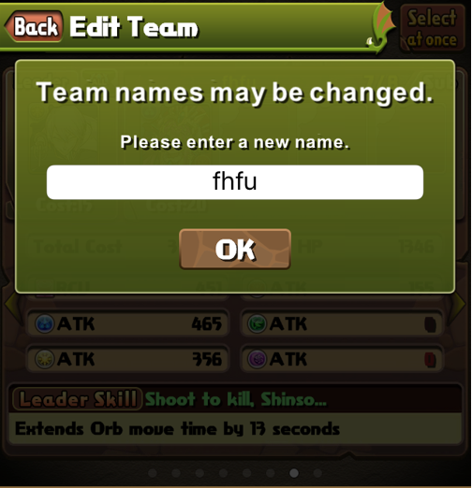

Figure : Editing Team Name

#### Renaming Teams

Each team is given a default name, a player can change that name to suit their needs easily. Simply select the team name and input the desired name.

**NOTE:** A team name can only be 10 characters long.

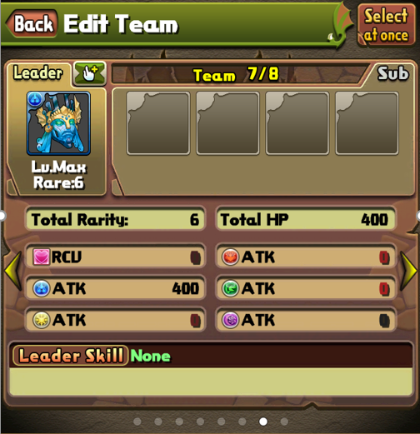

Figure : Edit Team Screen

#### Unlocking a Team

Each player begins with 6 teams, but as they rank up players can unlock additional teams. A player unlocks a new team slot every 100 ranks.

**NOTE:** As all teams must have a leader, once a team is unlocked, a leader is chosen by default.

### Dungeon Gameplay

The basics of dungeon gameplay is a player entering a dungeon where they match orbs of the same type to create combos.

* Monsters on your team with the corresponding orb types will attack.
* Creating certain combos will allow you to activate certain leader skills as well as certain awoken skills.

Dungeon gameplay is split into three main sections:

* Single player gameplay
* 2-player mode gameplay
* 3-player mode gameplay

#### Single Player Gameplay

Single player gameplay is the simplest process. It consists of:

* Player selecting a dungeon of choice
* Player choosing a helper or choosing to enter without helper (or challenge mode when available)
* Player choosing a team to enter the dungeon with and entering
* Defeating all monsters on a floor to proceed to the next
* Clearing all floors to complete the dungeon
* Claiming rewards upon exiting the dungeon

If your health reaches zero with the dungeon, you are either able to pay one magic stone to continue or give up and exit. Giving up will result in no stones.

#### 2-Player Mode Gameplay

2-Player mode gameplay is similar to single player with some key differences.

* It starts off with a player choosing a dungeon and inviting another player or players to join their room
* Once the other player has accepted, then both players choose their team and press ready/play
* Once in the dungeon the players take turns matching orbs
* Defeating all monsters on a floor to proceed to the next
* Clearing all floors to complete the dungeon
* Claiming rewards upon exiting the dungeon

Unlike in single player mode, the helper monster in 2-Player mode is the leader monster of the other player in the room. If a player disconnects then the game is switched to single player mode.

#### 3-Player Mode Gameplay

3-Player mode gameplay is somewhat of a mixture between single player mode and 2-player mode.

* It starts off with a player choosing 2-player or 3-player dungeon mode
* The player chooses a dungeon and chooses their monster leader.
* They then invite another player or players to join their room
* Once the other player(s) have accepted and chosen their helper leaders, then all players choose their team and press ready/play
* Once in the dungeon the players take turns matching orbs
* Defeating all monsters on a floor to proceed to the next
* Clearing all floors to complete the dungeon
* Claiming rewards upon exiting the dungeon

As in single player mode, players will use their chosen helper and not the helper of the friend(s) that entered with them. Like in 2-player mode, if one player disconnects, then the game will continue with the other player(s).

**Game play description**

The core gameplay from dungeons remains the same. However, the turn order must accommodate the extra player(s). The order will begin with the player who has created the Room followed by the other player(s). (If 3 players are present, the 2nd player to join the Room will go next, followed by the 3rd player to join the Room.)

## Stakeholder Requirements Definition Process

## Requirements Analysis Process

## Requirements Engineering Activities in Other Technical Process

## Requirements Management

# Information Items

# Guidelines for Information Items

# Information Item Content